Irregularity analysis on Moldova parliamentary elections.
February 24th, 2019.

The study was developed as part of the project “Watchdog.MD: Whistle-blowers in Energy and Public Policies in Moldova”, implemented with the financial support of the European Endowment for Democracy (EED). The content does not necessarily represent the official opinion of the EED. Responsibility for information and expressed views belongs entirely to the authors.

This analysis is devoted to discern some irregularities within the 24th February Moldova Parliamentary elections. Some of these problems are evident but most are hidden. Authors will use the different instruments of mathematical statistics to uncover such irregularities and electoral fraud like:
- irregularities on polling stations;
- tricks with electoral activity (turnout);
- tricks with statistical indicators;
- mysteries of the appearance/disappearance of the DPM electorate;
- disproportion between constituencies and territorial units.

Authors will use Chișinău and areas both simultaneously and separately to compare and to identify the differences.

Statistical instruments will be the same:
- analysis of means and deviations;
- analysis of pair and multiple correlation;
- analysis of regression to the mean;
- regression equations;
- analysis of partial correlation.

Finally, we will try to analyze „share” and „value” of each irregularity in the case under investigation.

For the sake of simplicity, we shall begin our discussion of irregularities of February 24th, 2019 parliamentary elections with the most apparent and accessible data, successively addressing more complicated issues. As will be seen below, there is an abundance of facts to do this.

First, we must consider polling stations which have evidently doubtful results.
In contrast to 2014 elections, where there were no polling stations with such kind of irregularities, in 2019 there have been a lot of it. This is itself evidence of nature of this elections. Let us consider only those constituencies, where share of votes for DPM and Șor Party has met the following inequality (https://books.google.ru/books/about/How_to_use_and_misuse_statistics.html?id=t_-CAAAAIAAJ&redir_esc=y, http://eruditor.ru/k/?16)
:

M_{i} > M₀ + 3ϭ,

Where M_{i} is share of votes for the party in a particular polling station, M₀ is its mean share of votes in a given locality (In the present case Chișinău, as all suburban areas are treated as separate localities), 3ϭ is a double standard deviation.

Some notes.
1. Normal (or Gaussian) distribution and normalized deviation is the simplest method to discern any irregularities without sophisticated mathematical analysis.

2. All those deviations have to have some comprehensive explanation, otherwise it could be considered like doubtful.

3. Rule of 3ϭ is the simplest application of Gaussian – it means – 68 – 95.5 – 99.7 probability that this value is confident (Table 1). It would be enough that we use 2ϭ deviation, because we can obtain only 10 polling stations out of this interval. We have 26 within and some more just on border. At the first, we will take only 3ϭ rule. We can have only 1 (one) polling station out of 3ϭ interval, but there is lot of such cases now, and it’s the first time in electoral history in Chișinău.

Statistics for DPM are the same. M₀ (average) – 11.1, ϭ (deviation) – 2.0.
For “Sor Party” M₀ (average) – 6.0, ϭ (deviation) – 1.5.

For example, we will calculate normalized deviation for the very first case (23 constituency, 1 polling station). (14.7 – 6.0)/1.5 > 5.

Constituency | Polling  station | Location | DPM | “Sor Party” | Normalized  deviation | Peculiars
23 | 1 | Woodworking factory |  | 14.7 | > 5 | Isolated neighborhood
23 | 2 | Woodworking factory |  | 11.8 | > 3 | Isolated neighborhood
23 | 4 | Airport |  | 21.7 | > 10 | Isolated neighborhood
23 | 5 | Airport |  | 18.3 | > 8 | Isolated neighborhood
23 | 25 | Neighborhood | 30.7 |  | > 9 | Hospital
25 | 10 | Center | 19.8 |  | > 4 | Isolated neighborhood
25 | 23 | Neighborhood | 18.2 |  | > 3 | University hostel
25 | 25 | Neighborhood | 17.6 |  | > 3 | University hostel
25 | 30 | Neighborhood | 20.3 |  | > 4 | Hospital
25 | 31 | Neighborhood | 25.8 |  | > 7 | Hospital
26 | 18 | Center | 23.9 |  | > 6 | Hospital
27 | 2 | Center |  | 15.3 | > 6 | New far neighborhood
27 | 8 | Neighborhood | 27.5 |  | > 7 | Isolated neighborhood
27 | 24 | Neighborhood | 19.1 |  | > 4 | University and worker hostel
28 | 3 | Neighborhood |  | 12.8 | > 4 | New far neighborhood
29 | 11 | Center | 26.4 |  | > 7 | Include prisons
30 | 23 | Neighborhood | 17.4 |  | > 3 | New far neighborhood
30 | 25 | Neighborhood | 23.3 |  | > 5 | New far isolated neighborhood

Table 1. Irregularities on polling stations, Chișinău, 2019 Parliamentary elections.

1. There are a total of 18 “suspicious” polling stations which makes up more than 7% of the total. Next 26 polling stations (more than 10%) with DPM and “Sor party” results stay near the “border” of 2ϭ. It’s incredible amount, keeping in mind that one doesn’t need any sophisticated methods to observe these deviations; they are quite apparent.

2. Deviations of “Șor party” are simultaneously larger and localized, while in the case of DPM, they are more spatially distributed. Largest ones in the latter case are connected with special and unusual polling stations most amenable for influence peddling, such as hospitals, hostels and prisons.

3.There have been irregularities in almost all constituencies. To the least they have took place in the most “leftist” constituencies (i.e. №24 and №28), and №26. The latter case is special, because of the most intensive struggle between Acum and PSRM candidates which resulted in difference just in 100 votes in this single member constituency.

Some preliminary conclusion:

1. Electoral fraud have certainly taken place. However, to quantify them one needs more sophisticated statistical methods.

2. These methods will be used at the same time to explore qualitative (which are connected to electoral activity) and quantitative (which are connected to internal correlations of the DPM electorate) indicators.

3. Therefore, it would be possible to determine quantitatively amount of falsifications both in Chișinău and in Moldova.

Tricks with electoral activity.

The correlation of dynamics (i.e. changes during the period under review) of electoral activity and results of major parties is considered as one of the most important indicators of presence or absence of electoral fraud (http://www.vokrugsveta.ru/nauka/article/157463/,
http://www-personal.umich.edu/~wmebane/apsa09.pdf).

Some notes.
1.Such shifts are quite usual for some cases. Indeed, ethnic minorities and their parties (representatives) are generally considered to be more passive during electoral process.

2.For example, there is a lot of literature concerning passivity of Afro-Americans in the US elections (http://www-personal.umich.edu/~wmebane/apsa09.pdf). In the Baltic countries Russians are usually much more passive than native population. In the recent Ukraine presidential elections, Zakarpattia, Odessa and Chernivtsi regions which are the regions with the maximal concentration of ethnic minorities, have all shown the least electoral turnout (https://www.cvk.gov.ua/pls/vp2019/wp063pt001f01=719.html).

3.Moldova usually serves as a counterexample to this consistent pattern although some fluctuations occur. To adjust them, changes in activity are considered instead of activity itself. It helps to avoid bias and clarify the whole picture.
We’ll take into account some details which are specific to Moldova.

Some Moldova details.

1. As a whole, since the first “relatively free” elections in 1989 and completely free 1990 elections, electorate in the city of Chișinău is divided between nominal “Russian-speaking” (left-wing) and “Moldovan” (right-wing) blocks. It’s enough to say that all elections with second tour voting in Chișinău since 2011 (mayor elections in 2015 and 2018(cancelled), presidential elections in 2016) have ended absolutely the same result. The “left-wing” candidate has got a bit more than 50%, while the “right-wing” a bit less than 50%. The only example of some “third force” getting more than 10% was Silvia Radu with 16.7% in the first tour of 2018 mayor elections.

2.”New edition” DPM (after 2009) had begun from a good result in Chișinău. Then it worsened a lot. DPM got 2.2% and 2.7% of votes in 2015 mayor and municipal council elections respectively, while in 2016 presidential elections there was no DPM candidate at all.

3. Hence, the 2016 statistics is inapplicable, while 2015 statistics is applicable to a limited extent. So, we’ll use 2014 as a reference. It should be noted that 2014 elections have been one of the most competitive during all the history of independent Moldova, consequently minimizing electoral fraud.

Let’s consider again some statistical indicators, such as correlations. Some of them can be very large, for example, correlation between share of votes for one or another party and of electorate cluster.

Indeed, one can find factors ruling level of support of a particular party which are highly dependent of territory. For example, Poroshenko has won with a landslide presidential elections in Lvov, while gaining less than 25% of votes in the country as a whole. This implies, there is some distinct category of electorate (let’s call it for convenience’ sake “Galician relatively high-income urban electorate” which has given more than two thirds of their votes for Poroshenko. In comparison, in Russian-speaking regions of Eastern and Southern Ukraine, Poroshenko has got less than 5% of votes (https://www.cvk.gov.ua/pls/vp2019/wp301pt001f01=719.html). However, even this huge difference isn’t maximal; moreover, both in Ukraine, Romania, Moldova and so on there are cities, districts and regions which are even more different in terms of electoral results.

Nevertheless, when we consider electoral turnout differences, we’ll see them being much smaller. Even 10-15% is a huge deviation. It has never been observed during the whole history of independent Moldova. 30% decrease of turnout is an upper bound even in the case of districts in the USA where Afro-Americans live in high concentrations (some researchers regard this case as an absolute limit). As usual turnout would be approximately 60%, 30% decrease means a twofold decrease. There are very few such examples in the political practice of the modern Europe that occur only as a result of severe discrimination or extremely strained interethnic relations (Kosovo might serve as an example) (https://web.archive.org/web/20170614094558/http://rezultatet.kqz-ks.org/Results.aspx?RaceID=1&UnitID=1&IsPS=0&Turnout=0&LangID=2). History and present of Moldova has nothing to do with this situation.

However, 2019 statistics suggest otherwise.

Сorrelation coefficient – change of electoral turnout (%) and 2019 elections DPM votes (%) | Year to year | Coefficient
 | 2019 to 2014 | 0.34
 | 2019 to 2018 | 0.45

Table 2. Correlation coefficients based on change of electoral
turnout (%) and 2019 elections DPM votes (%)

Both indicators show moderate correlation, though in the light of above, it is an extremely high value. By constructing and solving a regression model, we obtain a very peculiar result. Each percent of turnout increase results in 0.95% increase of DPM support. I.e. almost all “additional” voters have voted for DPM (the rest of them have voted for Șor Party). The results, summarized in Table 2 just cannot
be higher than they are; otherwise 100% growth in electoral activity.

As it can be seen of Picture 1, such difference in electoral activity is a very recent phenomenon. Indeed, it hadn’t manifested so acutely before 2018. May be in some regions situation was different (it will be discussed separately), but until 2018 (for example, in 2014-15 elections) in Chișinău there were no turnout irregularities.

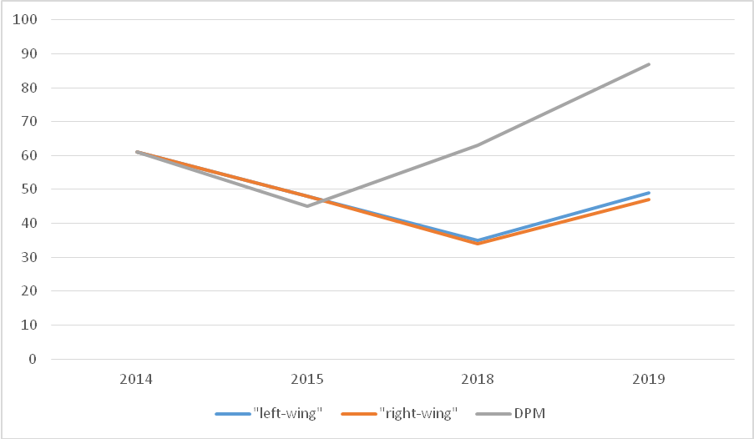

Picture 1. Electoral turnout for different Moldova political segments.

Tricks with activity: some conclusion.

1.”Left” and “Right” electorate demonstrate symmetrical turnout behavior, hence proving social roots of electoral activity. There has never been any ethnicity-related turnout shift in Chișinău during the period under review.

2.At the same time, DPM electorate is increasing its electoral activity since 2018, making it unbelievably high in 2019. It’s apparent that “DPM electorate” in this case is just a fake; however, there are no doubts that this fake was exactly what helped DPM gain 11% in Chișinău during 2019 elections.

3.Below we’ll try to identify what this “DPM electorate” can be and what it cannot be. Based on the data present in Picture 1 and Table 2 it is possible to make first quantitative conclusion: roughly half of votes for DPM are falsified, so their actual share is less than 6%. Furthermore, there are doubts that this 6% represent real votes too.

For “Sor party” it would little bit less – near 20-25% from all votes accepted in Chișinău. But this votes were decisive for “Sor party” to overcome threshold and to enter Parliament.

To be continued.

